**LEBANESE AMERICAN UNIVERSITY**

**USAID – HIGHER EDUCATION SCHOLARSHIP PROGRAM**

**HES - Volunteering Program Verification Form**

This form is to be used to document volunteering hours. If a student volunteers for multiple organizations, a separate form must be used for each organization. **This form must be turned in by the 28th of each month, the latest.**

I certify that the scholar Wissam Al Bahry completed a total of 5 hours of service at Life Sculptor.

The hours were completed hours as per the below:

Hours # 1 (date) _02/09 - 06/09_ (initials of supervisor) __A.K.___

Hours # 2 (date) _09/09 – 13/09_ (initials of supervisor) __A.K.___

Hours # 2 date) _16/09 – 20/09 (initials of supervisor) __A.K.___

Hours # 0 date) _23/09 – 27/09 (initials of supervisor) __A.K.___

Brief description of the activities the scholar performed or participated in:

I have completed a research about to Death and Grief,  
Theoretical Frameworks on Grief  
Stages of Grief (Kubler-Ross Model)  
Psychological Effects of Grief  
Coping Mechanisms and Support Systems  
Cultural Perspectives on Grief  
Long-Term Effects of Grief on Mental Health  
Conclusion and Implications for Further Research and I did a powerpoint presenting it

Written feedback about the scholar’s performance:

Wissam completed a thorough research on death and grief, including psychological effects, coping mechanisms, and cultural perspectives, along with a PowerPoint presentation. Strong, comprehensive work on an important topic

Please rate the overall performance of the scholar at your organization:

|  |  |  |  |
| --- | --- | --- | --- |
|  | Mastery (5) | Proficient (3) | Emerging (1) |
| **Problem solver** | X |  |  |
| **Engaged & Committed** | X |  |  |
| **Open-minded & multicultural** | X |  |  |

Signature

& stamp

__________________________

_

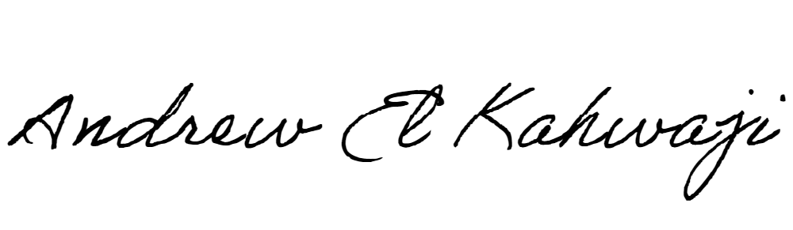

Printed Name _Andrew El Kahwaji_

Date __25/09/2024___

Email __andrew.lifesculptor.coo@gmail.com __

Phone __+961 71 914 378__

**LEBANESE AMERICAN UNIVERSITY**

**USAID – HIGHER EDUCATION SCHOLARSHIP PROGRAM**

